Exercice Altium Designer

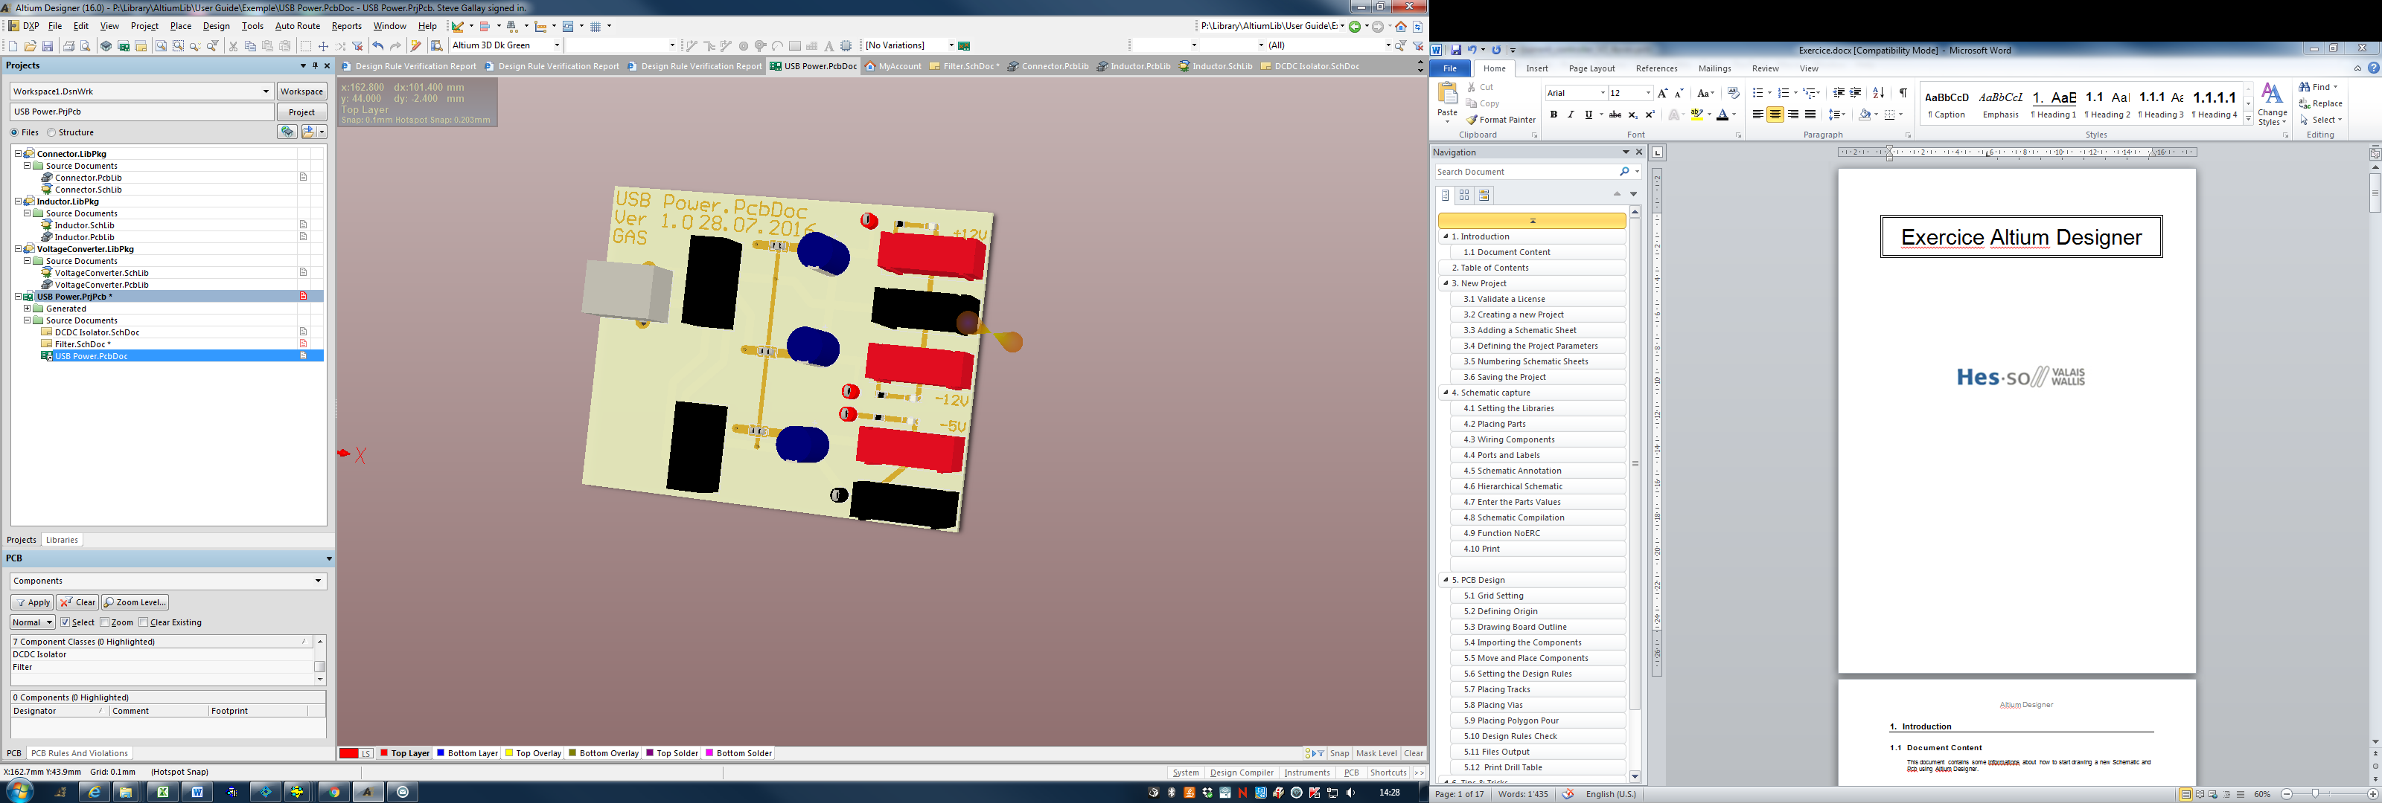

# **Schematic**

## **Schematic** Redraw exactly this 2 sheets of schematic.

## 



# **PCB**

## **Routing** Route all the nets of the board, run Design rules check and observe the pcb.

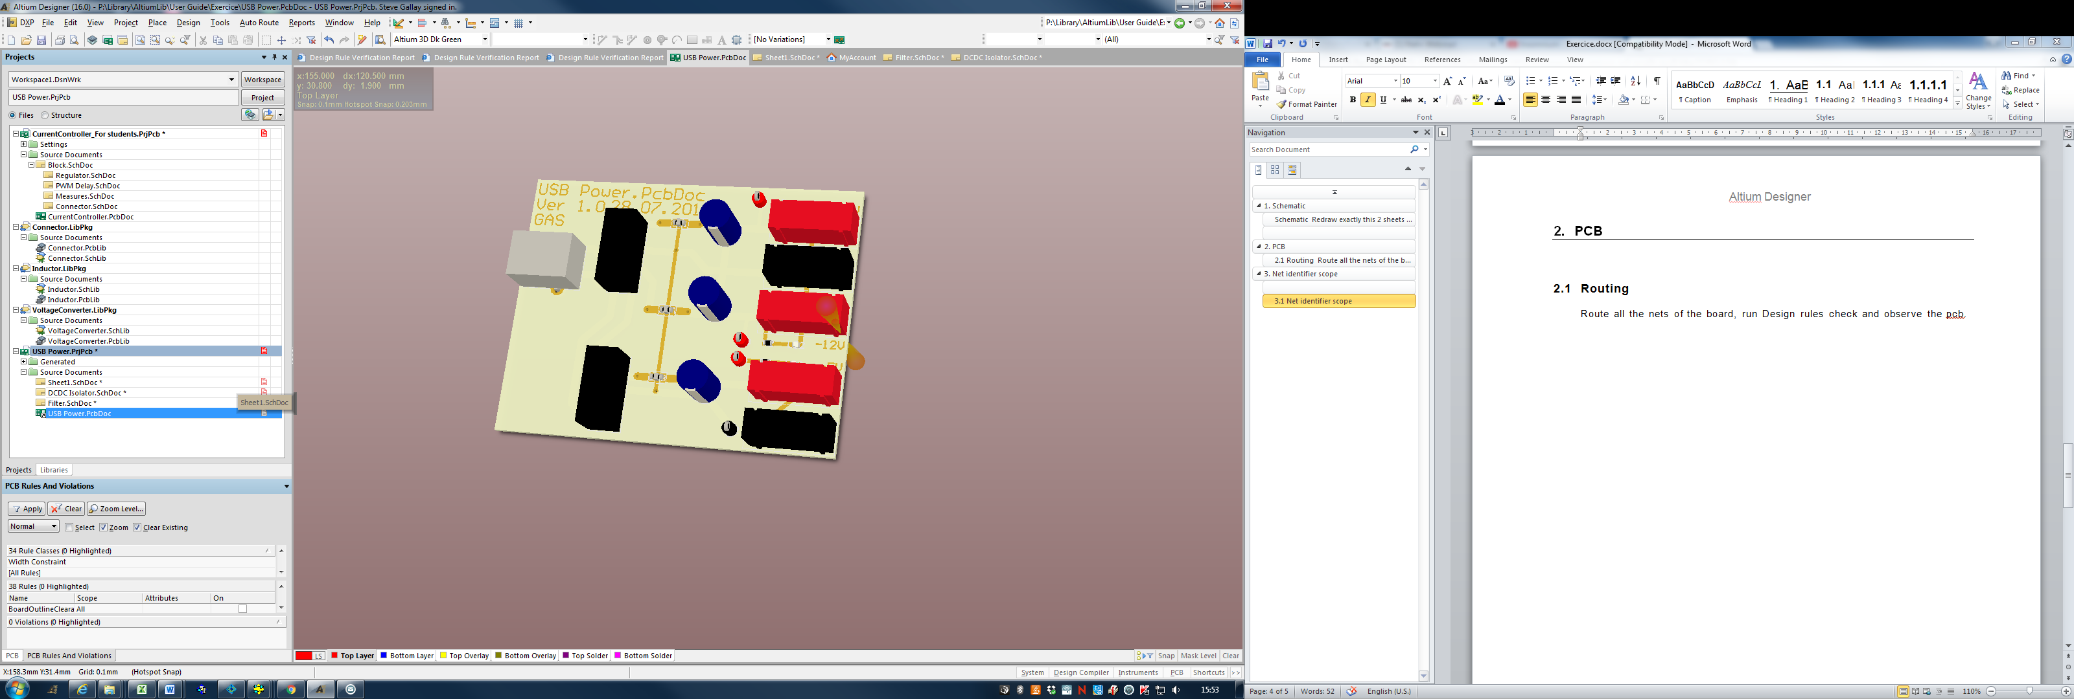

# Net identifier scope

## Net identifier scope

Try the different connection method in *Project->Project Options->Options->Net Identifier Scope*

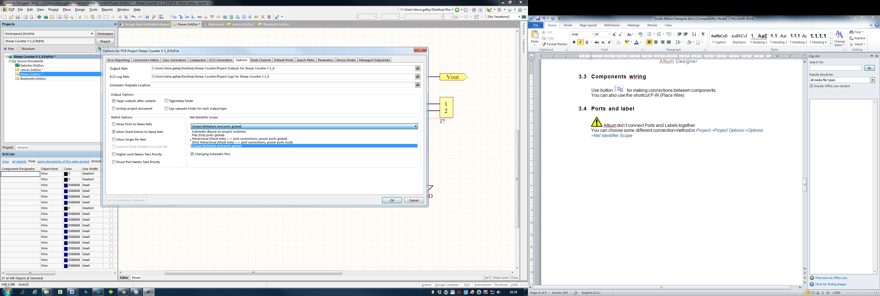

# **Hierarchical schematic**

## **Hierarchical schematic**

Add a new sheet and make a hierarchical schematic.

